**Output Screenshots:**

**Website Welcome page for Admin and User**

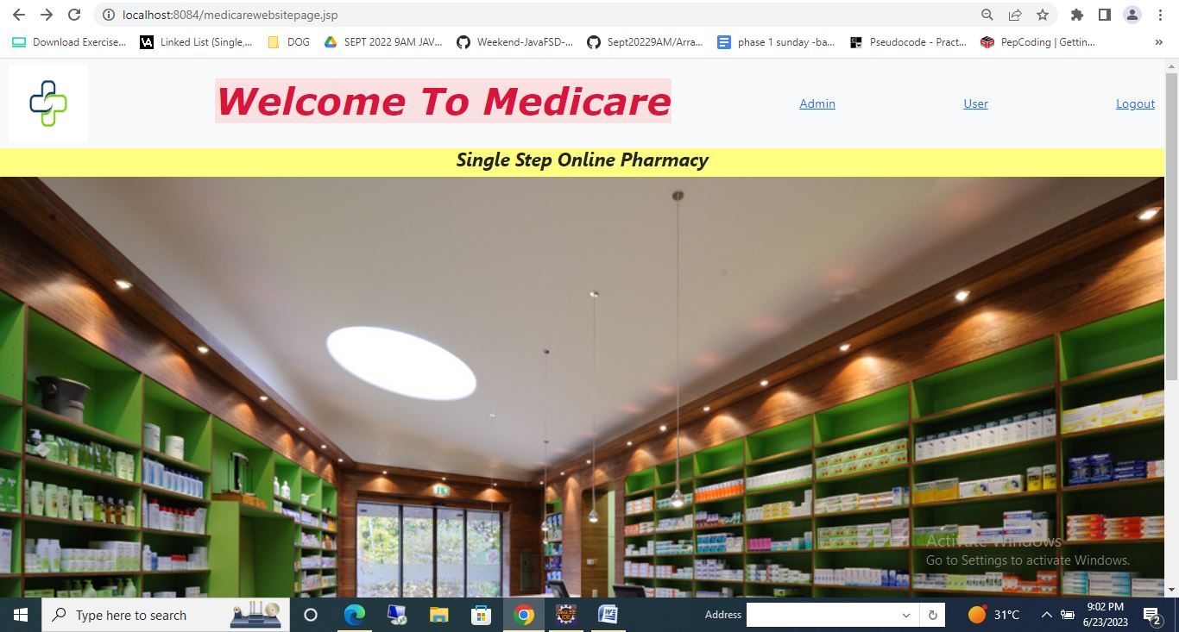

**Admin Login Page**

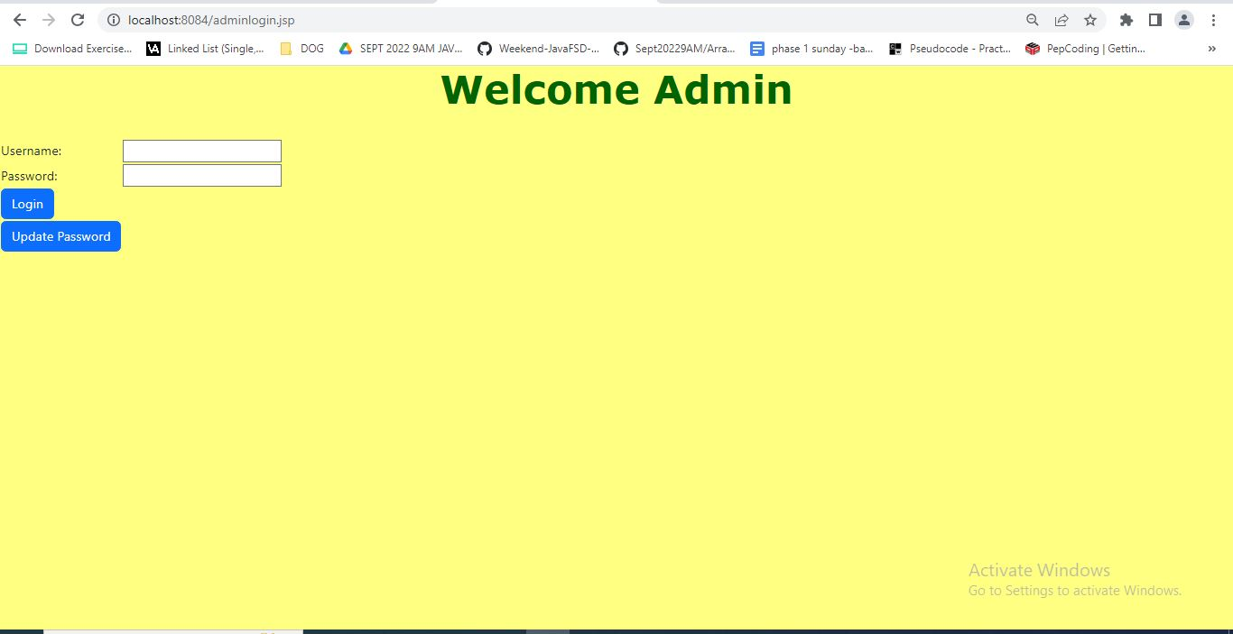

**Admin Update Password page**

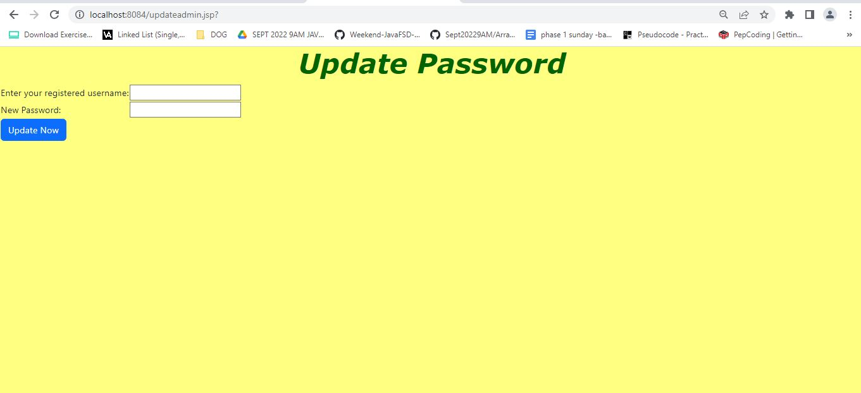

**Password Updated successfully**

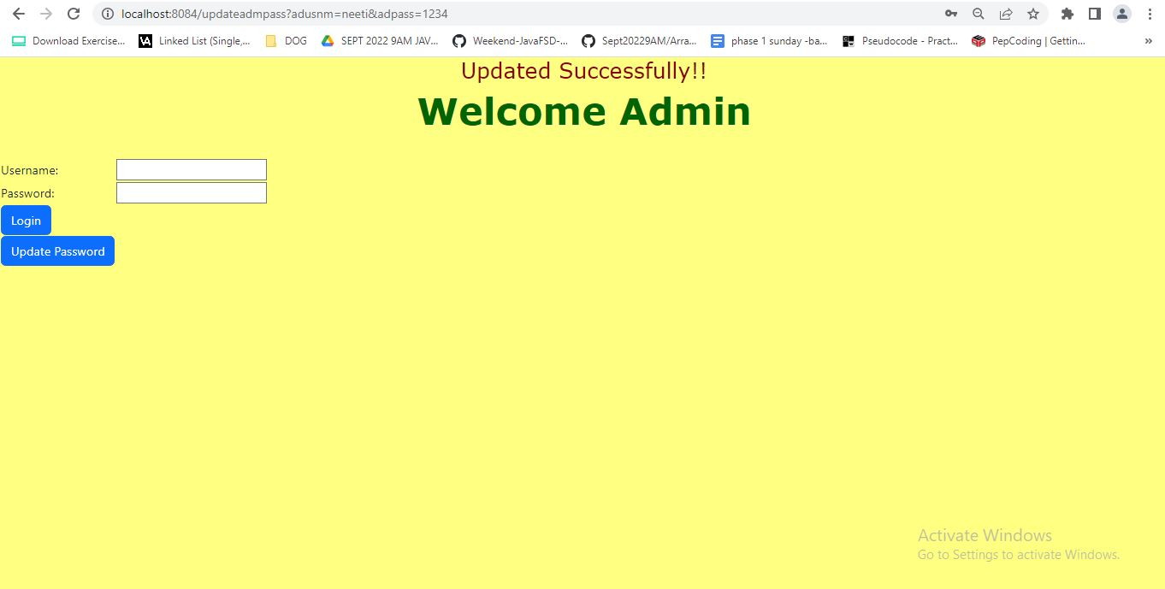

**Admin enters incorrect password:**

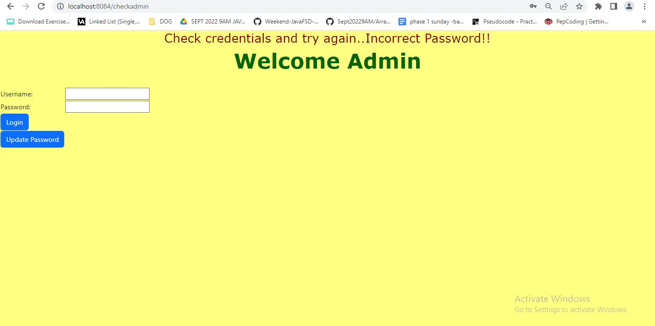

**Admin welcome Page**

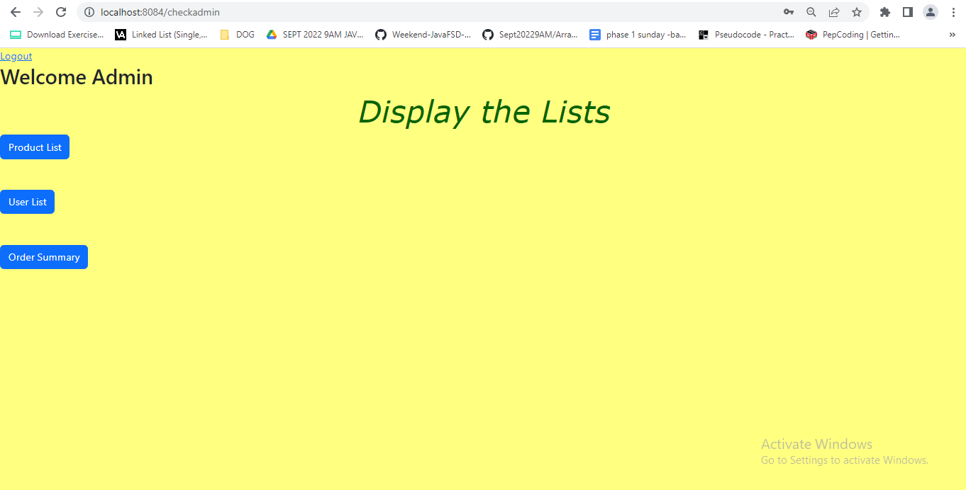

Admin can see the List of Products and can Insert , Search, Filter and Sort the products as per the requirement. Also, can Delete and Update the Products

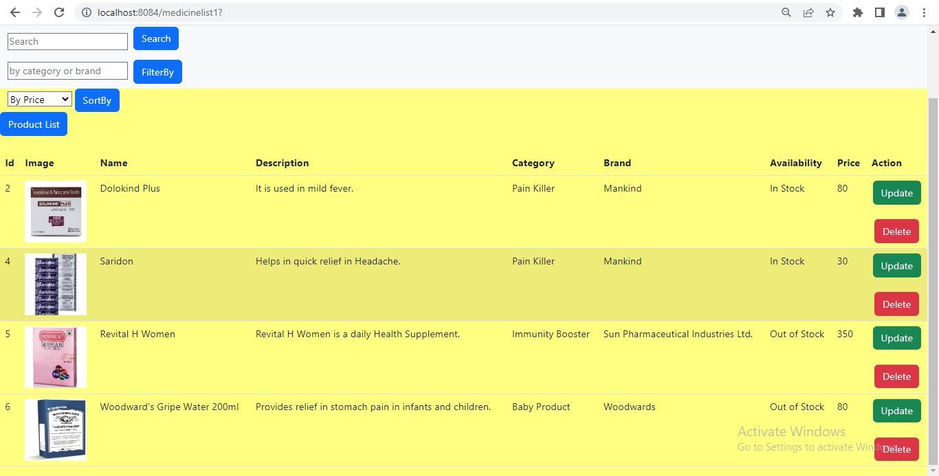

**Sorting list Low to High**

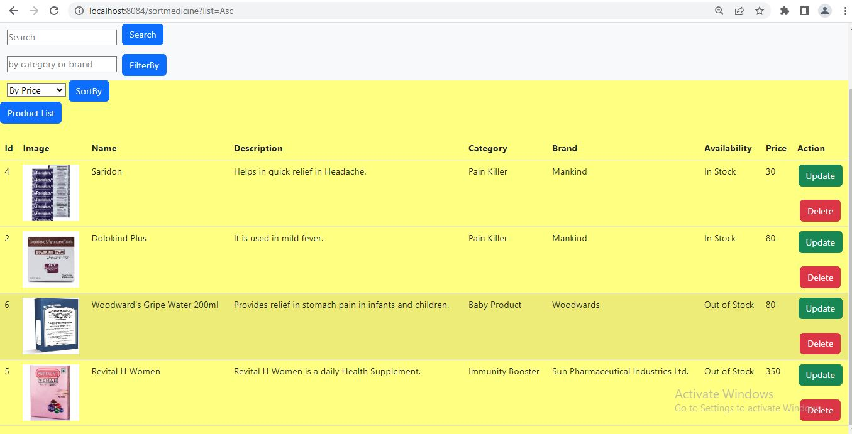

**Sorting list High to Low**

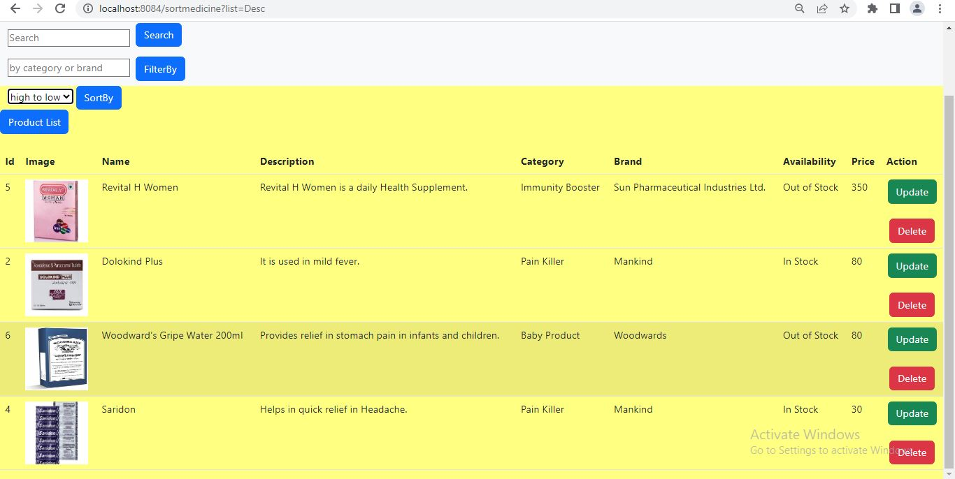

**Filter by Name**

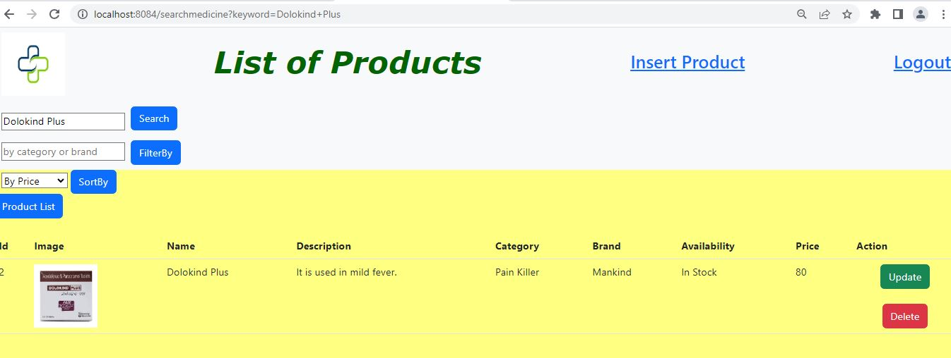

**Filter by Brand**

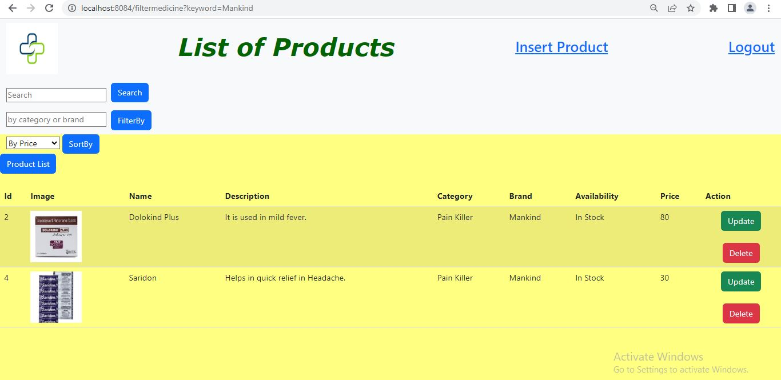

**Filter by Category**

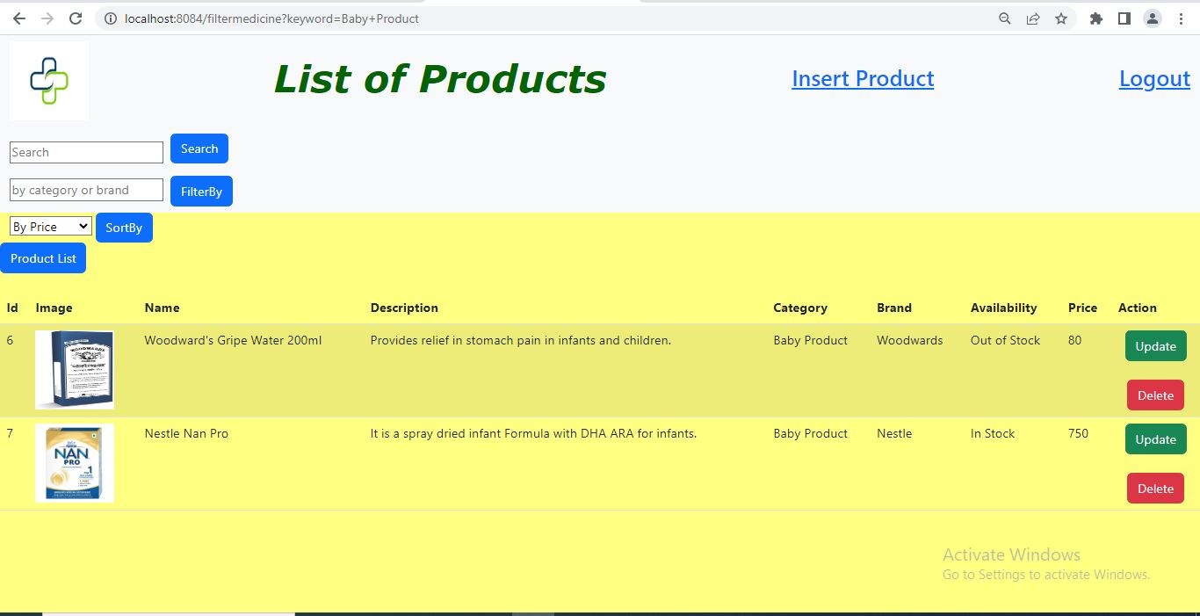

**Filter by Availability**

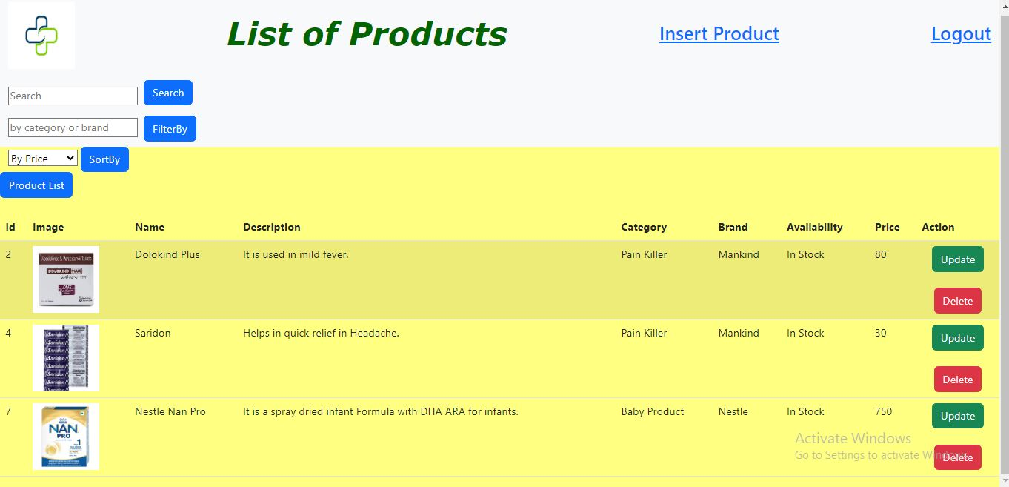

**Admin can insert Product with Image**

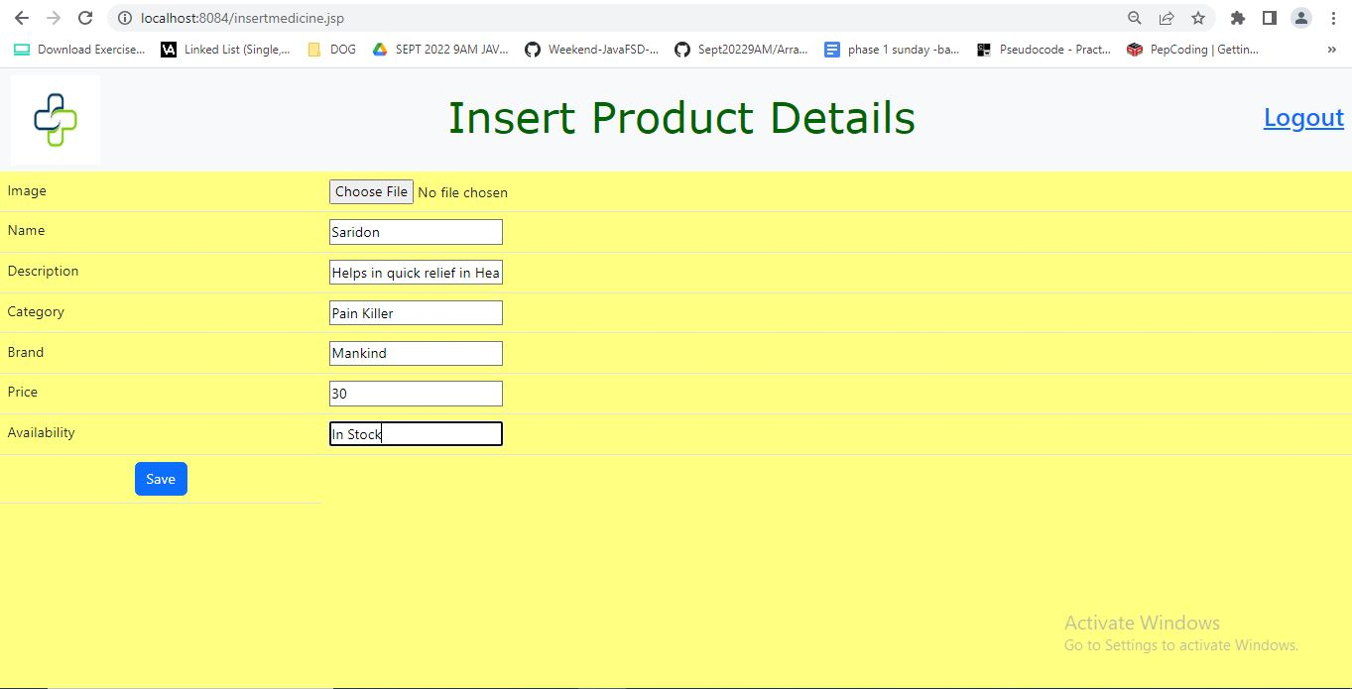

**Admin can update Medicine**

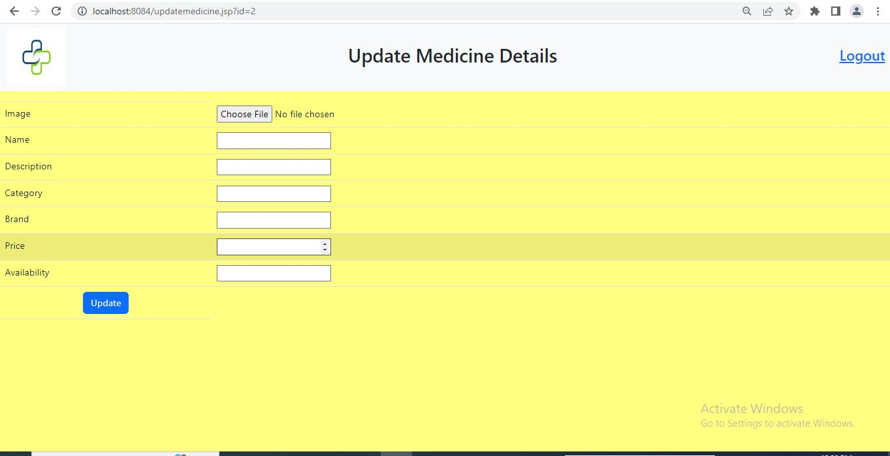

**Admin can See the List of Users and able to Delete the User**

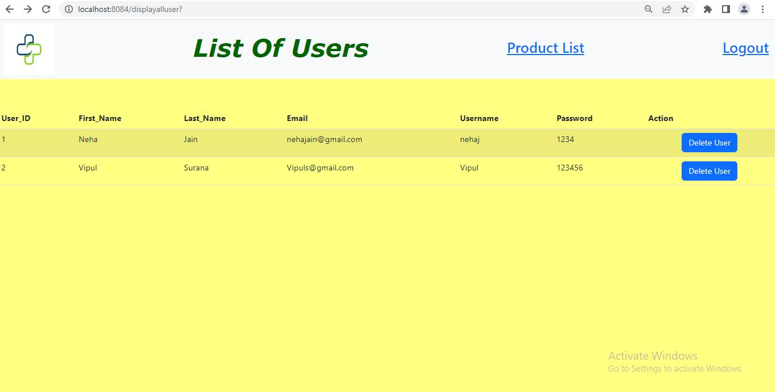

**Logout Page**

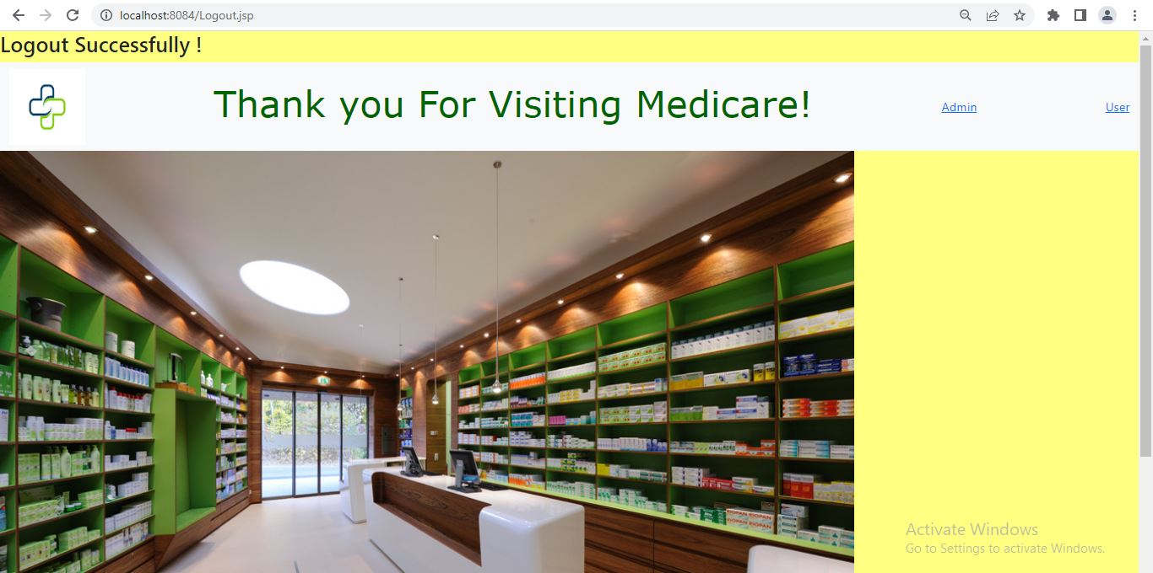

**User Login and Registration Page**

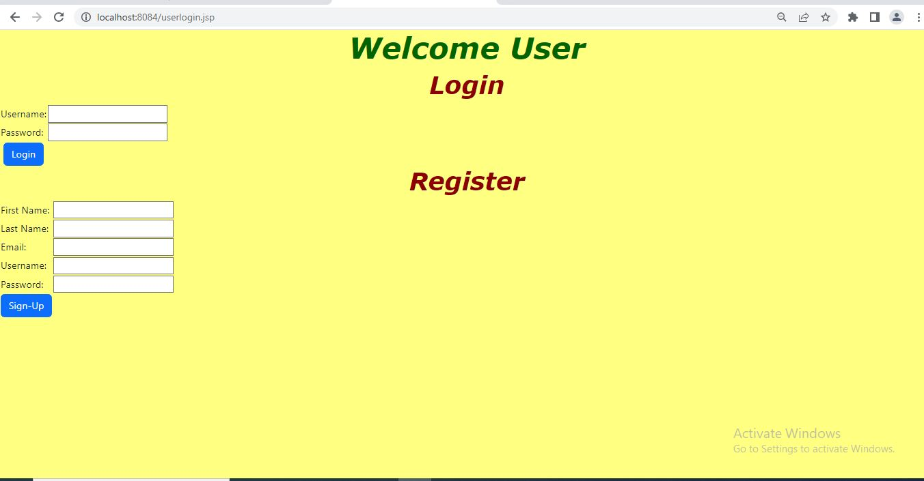

**Register Details**

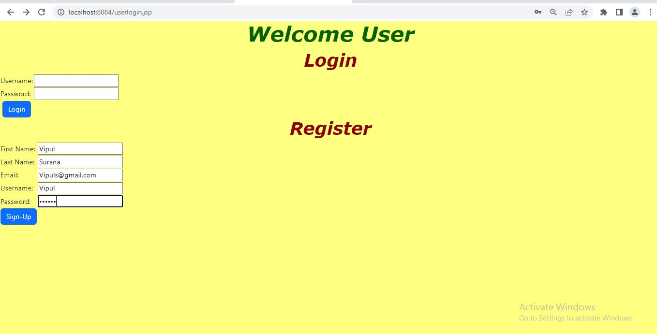

**User Home Screen**

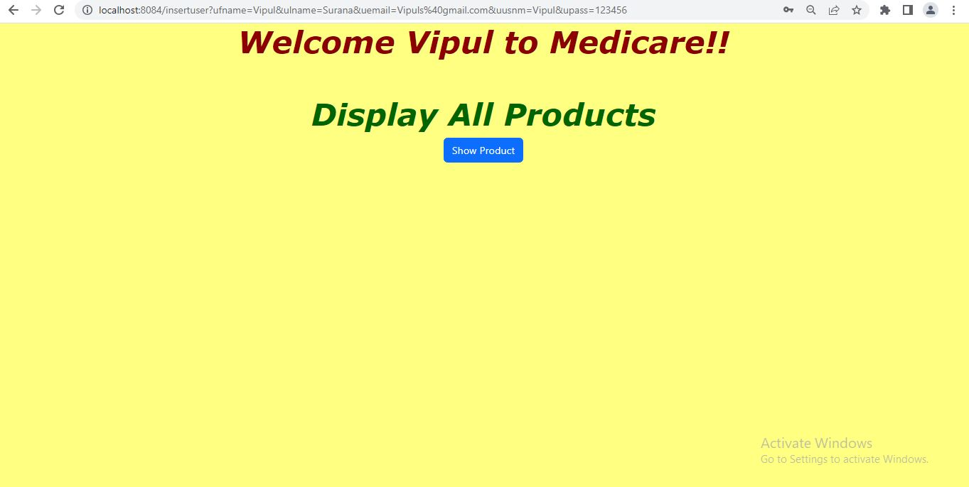

User can see the List of Products and can Search, Filter and Sort the products as per the requirement and can Add to Cart

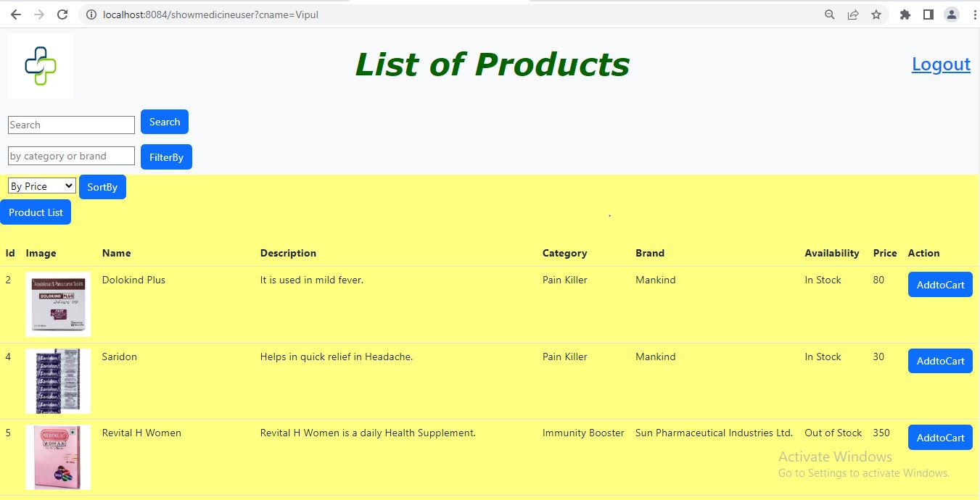

After adding into the Cart User can redirect to Cart details Page

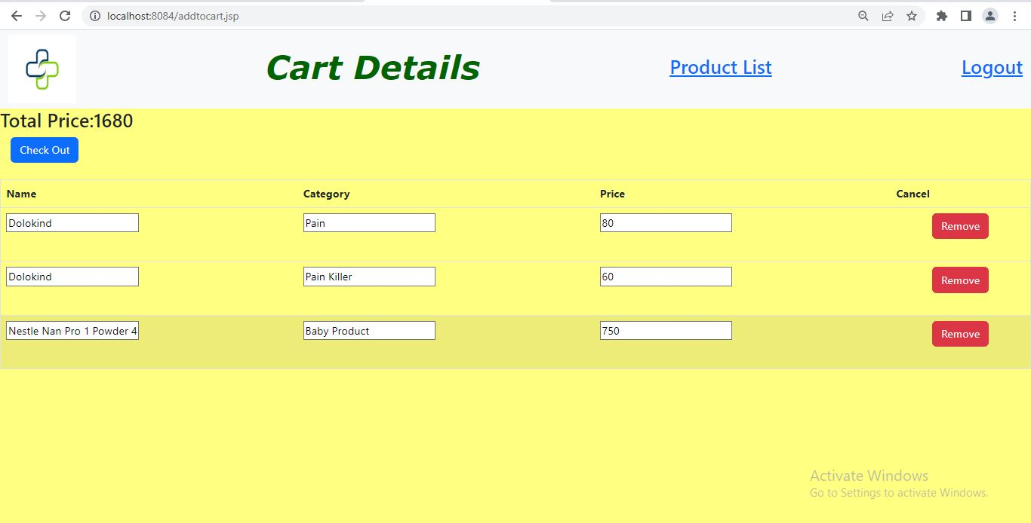

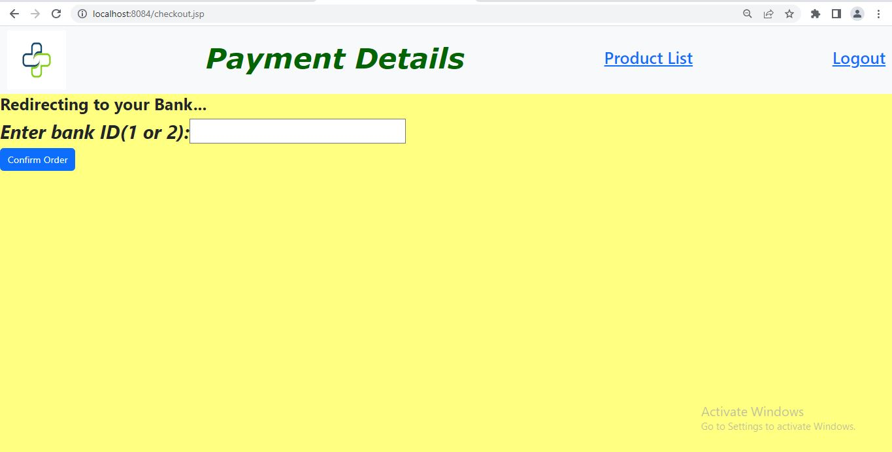

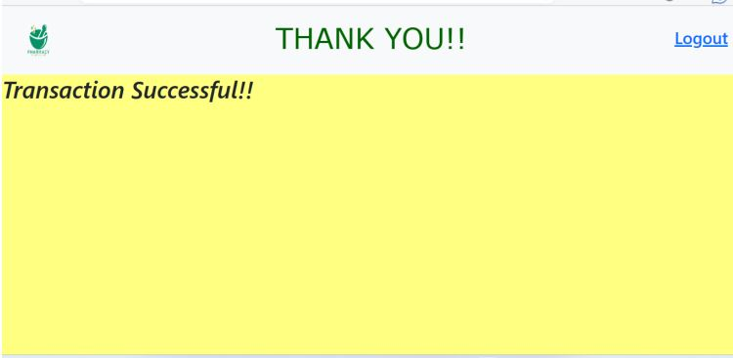

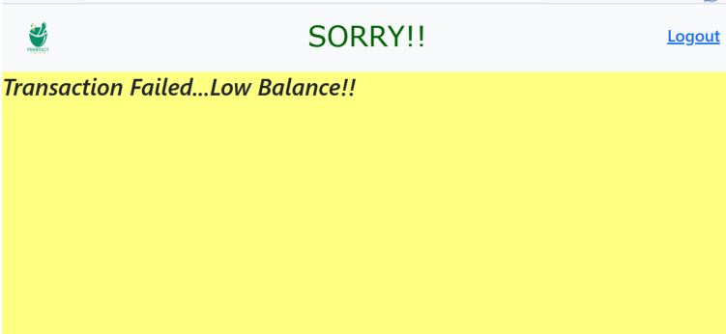

**Insert Admin by Postman**

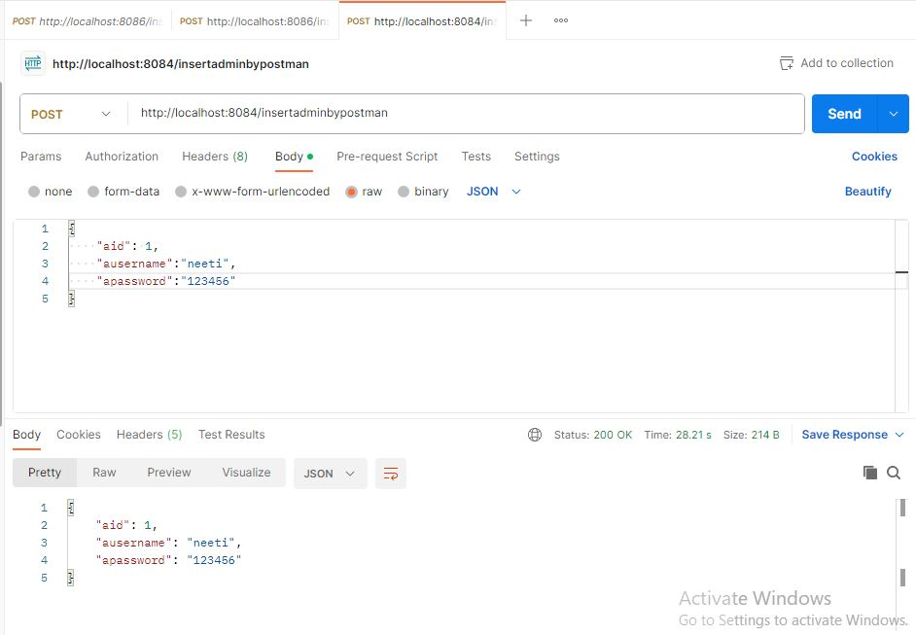

**Insert Bank by Postman**

